Dehydrated High-Protein Yogurt

ABE 55700

December 7, 2018

Phase 5

Group 1:

Chatterjee

Atherton

O’Neill

McAnulty

# Plackett-Burman DOE

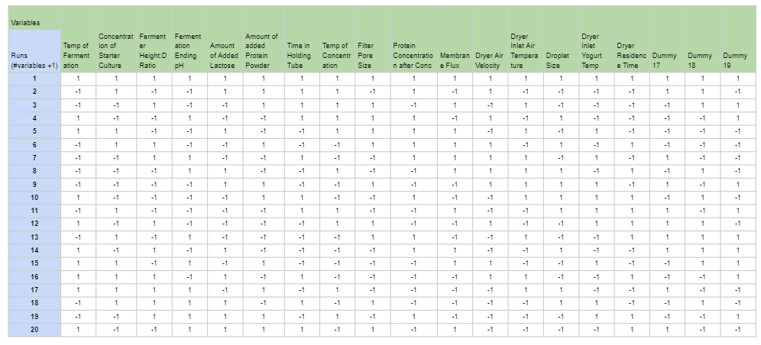

*Figure 1: Plackett-Burman DOE. Sixteen variables and three dummy variables were used over twenty runs.*

# *Table 1: Plackett-Burman DOE Minimum and Maximum Values for Each Variable*

|  |  |  |
| --- | --- | --- |
| Variable | +1 | -1 |
| Fermentation Temperature | 37 | 43 |
| Starter Culture Concentration | 3% | 1% |
| Fermenter Height to Diameter Ratio | 1:1 | 3:1 |
| Fermentation Ending pH | 4.4 | 4.2 |
| Lactose Added (kg/batch) | 51 | 45 |
| Protein Powder Added (kg/batch) | 1 | 0 |
| Time in Holding Tube (sec) | 20 | 30 |
| Temperature of Concentrate (C) | 40 | 60 |
| Filter Pore Size (μm) | 0.05 | 0.2 |
| Filtration Concentration Factor | 1 | 3 |
| Membrane Flux (L/(h*m2)) | 200 | 400 |
| Dryer Air Velocity (m/s) | 0.6 | 1.5 |
| Dryer Inlet Air Temperature (oC) | 150 | 180 |
| Droplet Size (μm) | 5 | 20 |
| Dryer Inlet Yogurt Temperature (oC) | 4 | 30 |
| Dryer Residence Time (sec) | 3 | 10 |

# Lab-Scale Experimentation

### Sterilization

Pasteurization, at the lab scale, was evaluated based on batch parameters and a streak plate to assess microbial reduction. With the equipment provided for the lab scale, a batch pasteurization method was implemented. Initially, 300 mL of skim milk was poured into a 500 mL beaker. A sample of the skim milk was taken and streaked on an LB agar plate and incubated at 37 ℃ overnight. A toaster oven heated the milk to an appropriate temperature and a power meter gave an idea of power consumption. A thermometer measured the temperature of the milk in the beaker and the ambient temperature of the toaster oven every 10 minutes. The milk needed to be heated to 65 ℃ and maintained for at least 30 minutes to eliminate pathogens and degradative enzymes. If the ambient temperature dropped below 75 ℃, then the temperature setting on the toaster was increased. The ambient temperature was set to a higher temperature than the desired to temperature to account for different resistances to heat transfer. After the milk was maintained at above 65 ℃ for at least 30 minutes, another sample was taken to be streaked on an LB agar plate and incubated 37 ℃ overnight.

When implementing the pasteurization procedure into experimentation, there were limitations with some of the equipment present. The most significant issue with evaluating the pasteurization parameters is that the skim milk used in the process was already pasteurized. It was too difficult to find raw, unpasteurized milk. The toaster oven also did not have accurate temperature control and had to be opened often to check the temperature of the milk and surroundings, which impacted the heat transfer coefficient. Lastly, LB agar plates were not present to evaluate the microbial reduction after following the pasteurization procedure. Power measurements were taken using the power meter. While the toaster oven was heating, the power meter read at 1387 W. It was estimated that the toaster oven was heating and only consuming power while the ambient temperature was increased to 75 ℃, which was 35 minutes, making the power consumption 2912 kJ.

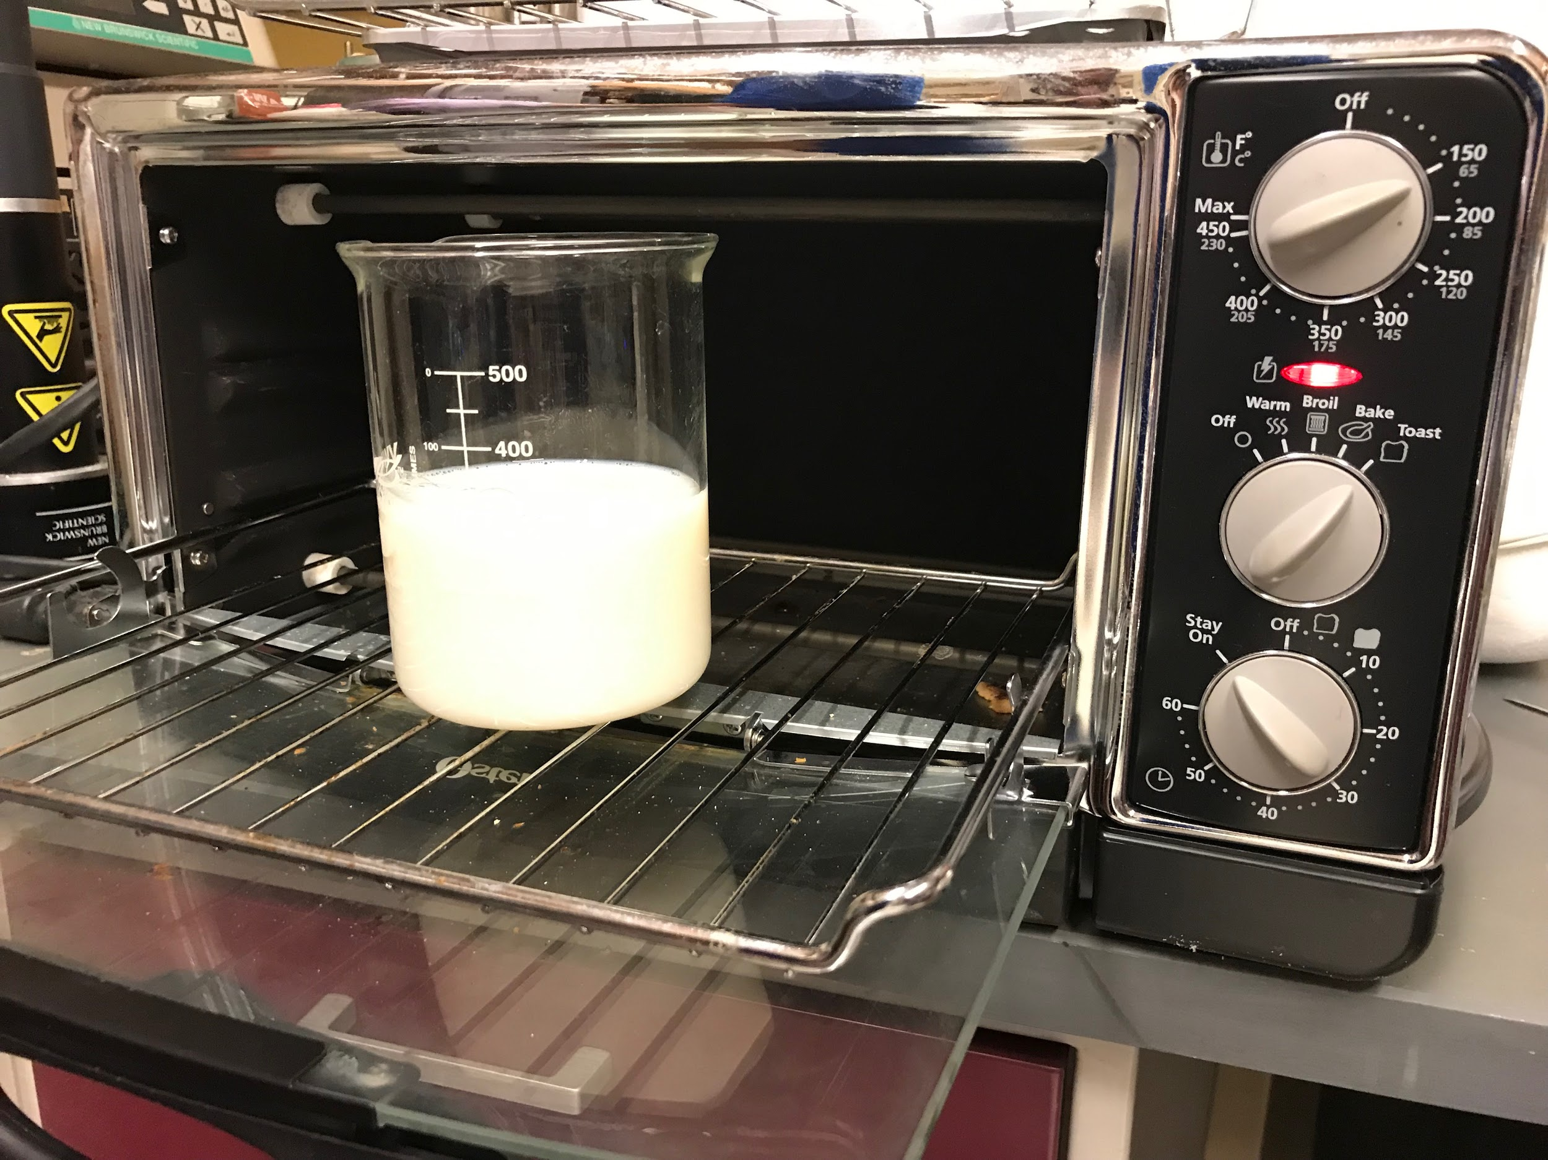

*Figure 2: Pasteurization instrumentation showing toaster oven and beaker with skim milk*

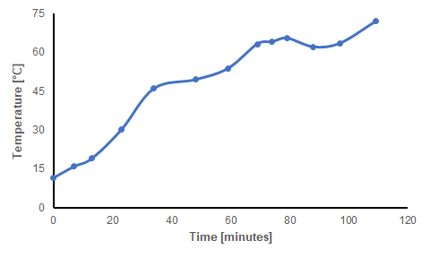

*Figure 3: Thermal data for skim milk during pasteurization procedure*

The skim milk pasteurized in the toaster oven was compared to the purchased skim milk to evaluate the quality parameters. It was desired that the pasteurization procedure would not alter sensory characteristics of the skim milk after processing and only remove the harmful microbes. The pasteurized skim milk was evaluated based on odor, consistency, and taste. The odor was enhanced in the pasteurized skim milk and smelled a bit sourer than the purchased skim milk. The consistency was equivalent between them. The experimental sample was not tasted this time due to the possibility of contamination from a previous sample left in the beaker. During further evaluations, the glassware will be cleaned prior to experimentation, so that the samples can be tasted as well.

### Concentration

The lab equipment required for the concentration step was not in an appropriate condition to perform a separation. When working, the provided ultrafiltration system depicted in Figure 4 will be used to simulate membrane filtration of the pasteurized milk. A single-pass filtration method will be used, and the retentate from the process will proceed to the fermentation step of production. The protein content of the initial and final streams will be compared to determine how well the concentration worked. Because of the variation in pore size between micro- and ultrafiltration, protein fractionation will not be achieved using this method, but the overall protein content can be tracked using the Kjeldahl Method. An additional spectrophotometry test such as an SDS-page gel can also be included to compare the amounts of separate protein species within each stream.

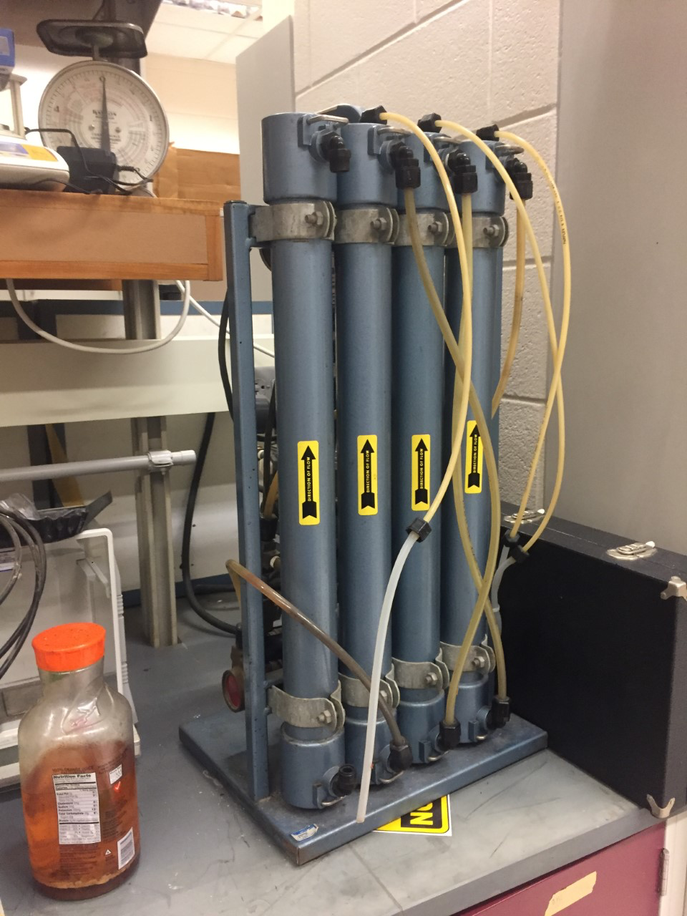

*Figure 4: Microfiltration system for lab scale experimentation*

### Fermentation

Given a limited number of hours in the lab, data collection on the full six-hour fermentation process was unrealistic, so this lab design purposefully simulated the yogurt fermentation process at varying extents based on pH. Lactic acid fermentation controls pH, a measurable quantity, and end product quality related to taste, a testable factor. Figure 5 shows the initial pH of the skim milk, Dannon yogurt, and each beaker mixture. The beakers increased in pH by about 0.2. While controlling pH by varying milk:yogurt ratios, other variables affected are: lactose concentration, starter culture concentration, and heat capacity. The exact stains and concentrations of live cultures in the yogurt could not be determined although the container mentioned live cultures, including *L. acidophilus*.

Neither the yogurt maker instructions, box, or the device itself indicated the operating temperature nor had a method of changing the temperature setting of the hot plate beneath the beakers. Temperature readings of the beakers indicate the hot plate setting may be 45°C. For each beaker, temperature and pH data were collected every 20 minutes during the 2 hours of fermentation.

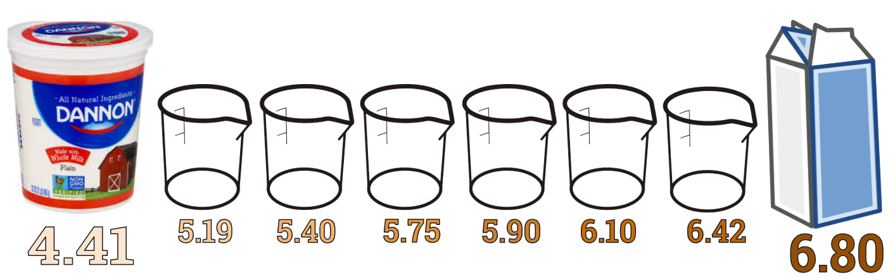

*Figure 5: Initial pH Gradient for Lab-Scale Yogurt Fermentation*

The beakers were not covered individually but were covered by a plastic lid over the entire area of the yogurt maker. Figure 6 shows an image of the six fermenting beakers in the yogurt maker. Qualitative observations include the thickening of the mixture over time and the formation of froth around the glass particularly in the beakers beginning at lower pH.

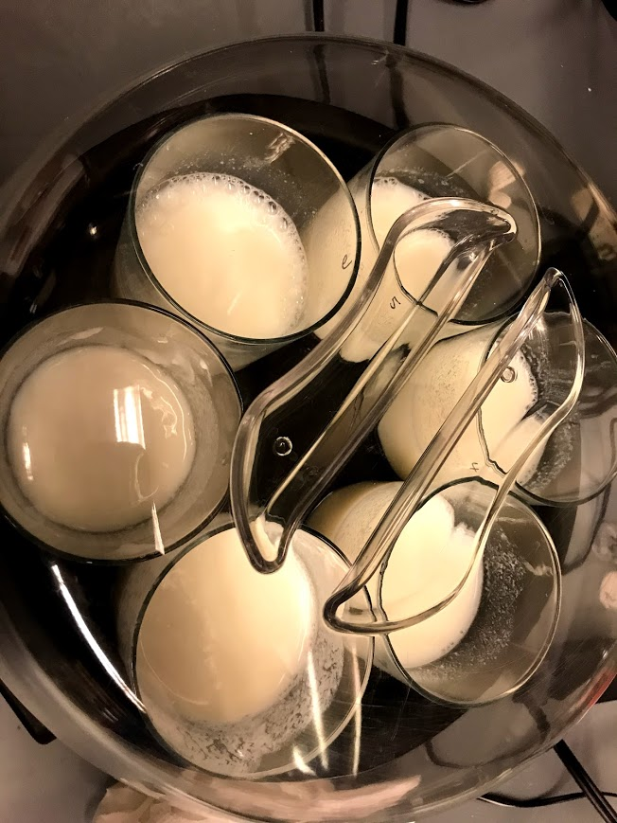

*Figure 6: Yogurt Fermentation Image in Yogurt Maker*

Figure 7 shows the graphical results of the two-hour lab-scale fermentation. Based on literature, expected results were that beakers around a pH of 5.5-4.8 would be decreasing in pH most quickly. In this lab experiment, beakers with higher starting pH had the largest drop in pH. One factor affecting the pH change was that the beakers were still heating up to steady state such that the cultures were behaving differently as temperature changed. Figure 8 shows the temperature during the fermentation.

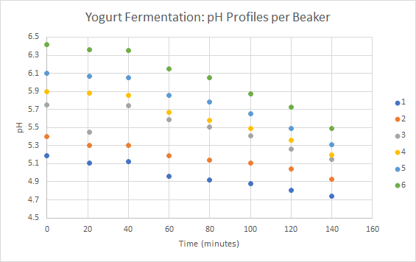

*Figure 7: Beaker pH Profiles over Time*

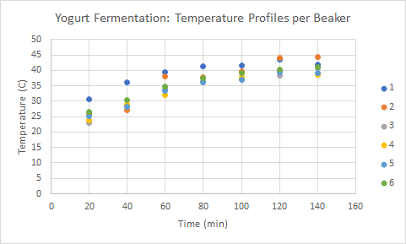

*Figure 8: Beaker Temperature Profiles over Time*

Power measurements were taken with a plug-in power meter, which showed the yogurt maker using either 0 or 36W at any given time. The yogurt maker likely operates with bang-bang control by turning on a heater when the temperature goes below range. 140J was the energy usage estimate for the 2-hour period, during which the clear plastic lid was removed several times for sampling and the beakers were still being heated to reach steady state. A fermentation without energy loss due to lid removal and where the beakers have reached steady state would use less energy.

### Drying

Spray drying equipment was unavailable for testing at this time, so an American Scientific Products Constant Temperature Oven Model DN-81 was used (Figure 9). The oven was heated to a temperature of 100oC and the yogurt, weighed and spread onto a baking sheet, was heated in the oven for thirty minutes. The yogurt was removed after ten minutes and re-weighed before being put back into the oven. From then on, the yogurt was removed and re-weighed every five minutes, then returned to the oven.

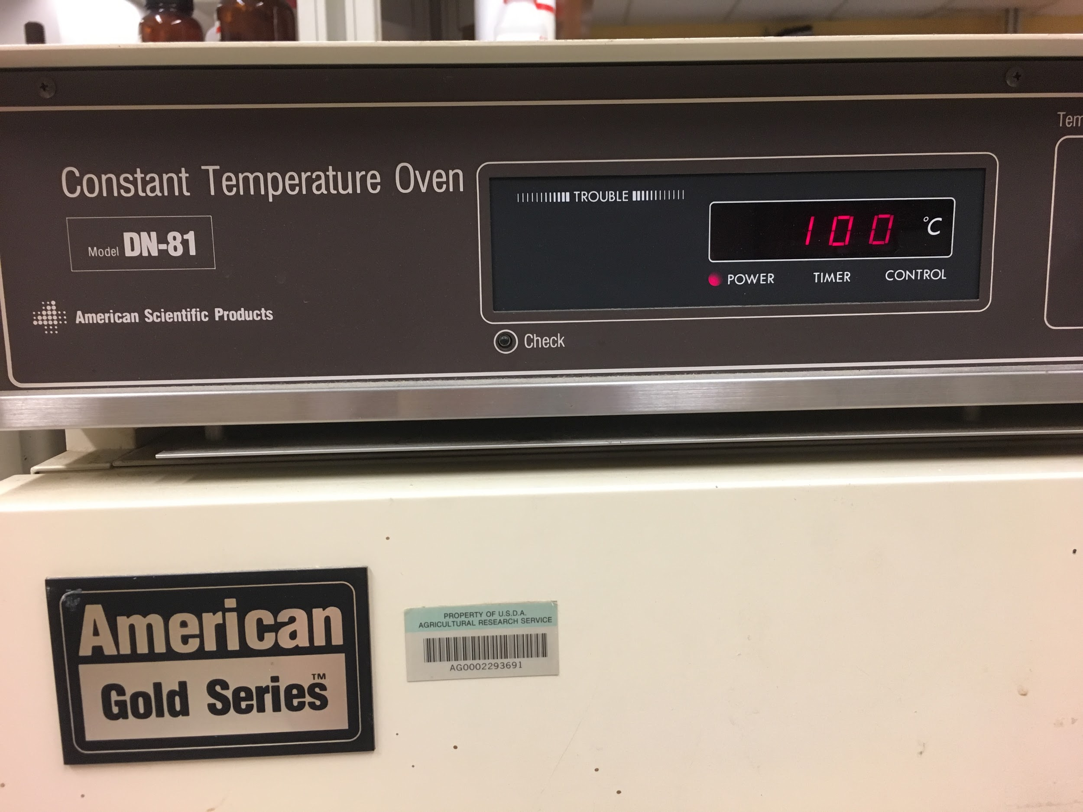

*Figure 9: The constant temperature oven used for preliminary drying experimentation. The oven was set to 100oC and the yogurt was dried for thirty minutes*

To find the original moisture content, the USDA database was searched to find the moisture content of typical Greek yogurt, 83%. This percentage was multiplied by the original mass of the yogurt found by zeroing the scale with the baking pan and then spreading the yogurt on the pan. The non-water mass was found and subtracted from the masses found at each measurement time to calculate the mass of water left after each time interval. The percent moisture content was calculated by dividing the water mass by the total mass. Moisture content was graphed over time in Figure 10.

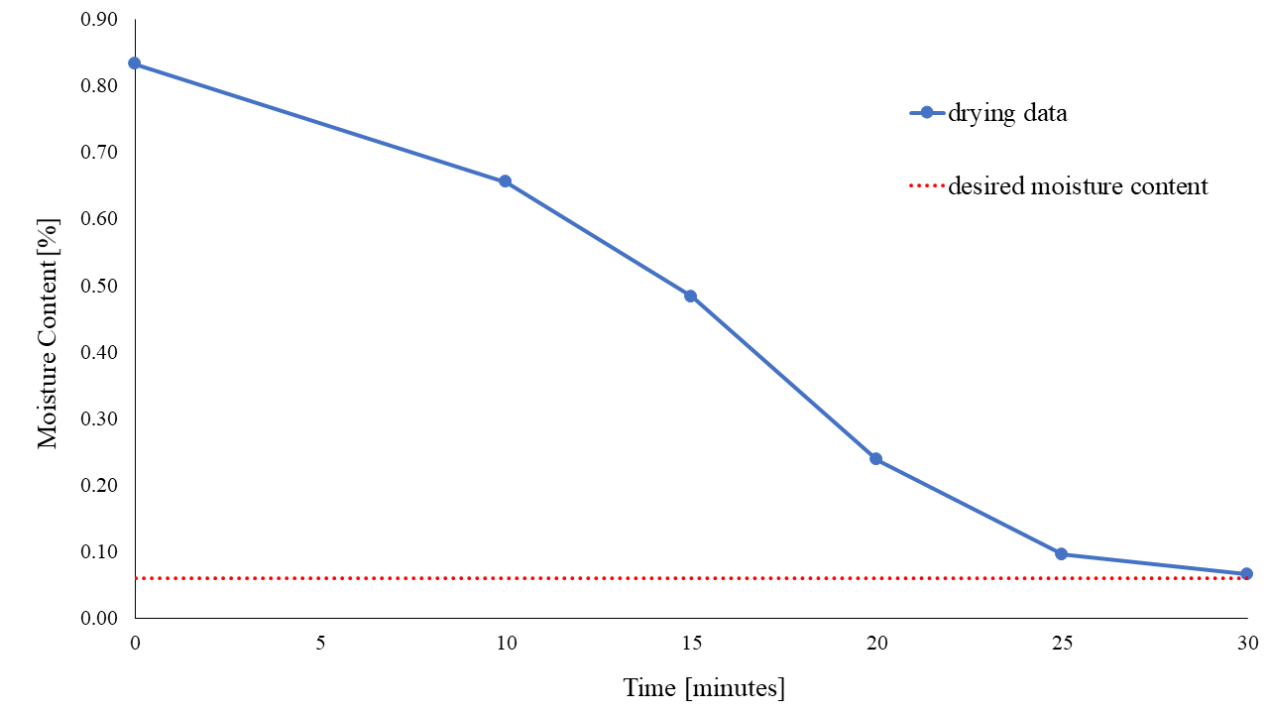

*Figure 10: Results of drying experiment, moisture content [%] versus time [minutes]. After drying in the oven for thirty minutes, the yogurt lost enough water to reach the desired moisture content.*

The yogurt was hard and crusty after the drying process as it had baked onto the pan. The comparison of the yogurt appearance before and after can be seen in Figure 11.

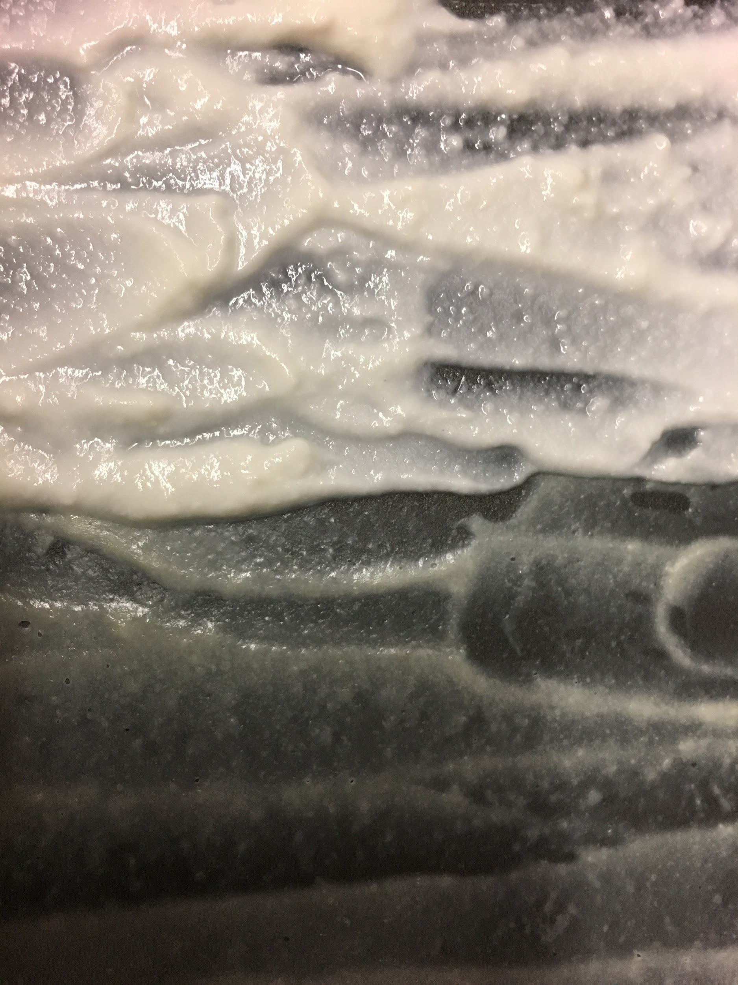

*Figure 11: The yogurt before drying (left) and after drying for thirty minutes (right).*

# Design Equations and Performance Curves

The designed pasteurization system is a continuous process that uses a plate heat exchanger to heat up the milk and then it is held in the holding tube. The area of the heat exchanger and the length of the holding tube are key parameters to design the sterilization system. The area of the heat exchanger can be calculated using an energy balance equation based on the heat generated by the heat exchanger and heating fluid. Once the area of the heat exchanger is found a flow rate through the pipe can be assumed based on an appropriate velocity. With a flow rate, a desired holding time of 25 seconds is used to calculate the length of the holding tube. The power requirement for each heat exchanger was also calculated. Sample calculations are shown in Appendix A. The primary variables for the heat exchanger design are shown in Table 2.

*Table 2: Primary variables for pasteurization set-up*

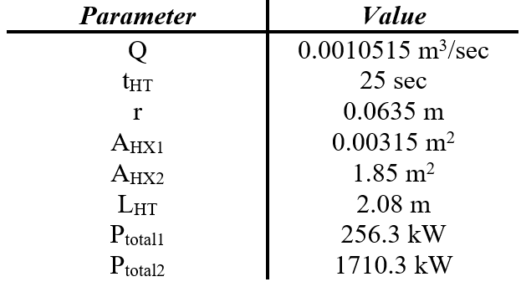

The theoretical performance of the heat exchanger will depend on the exit temperature of the milk stream as well as the mass flow rate the heating fluid. With an increase in mass flow rate there is an increase in the heat transfer coefficient inside the heat exchanger. This relationship can be shown in Figure 12.

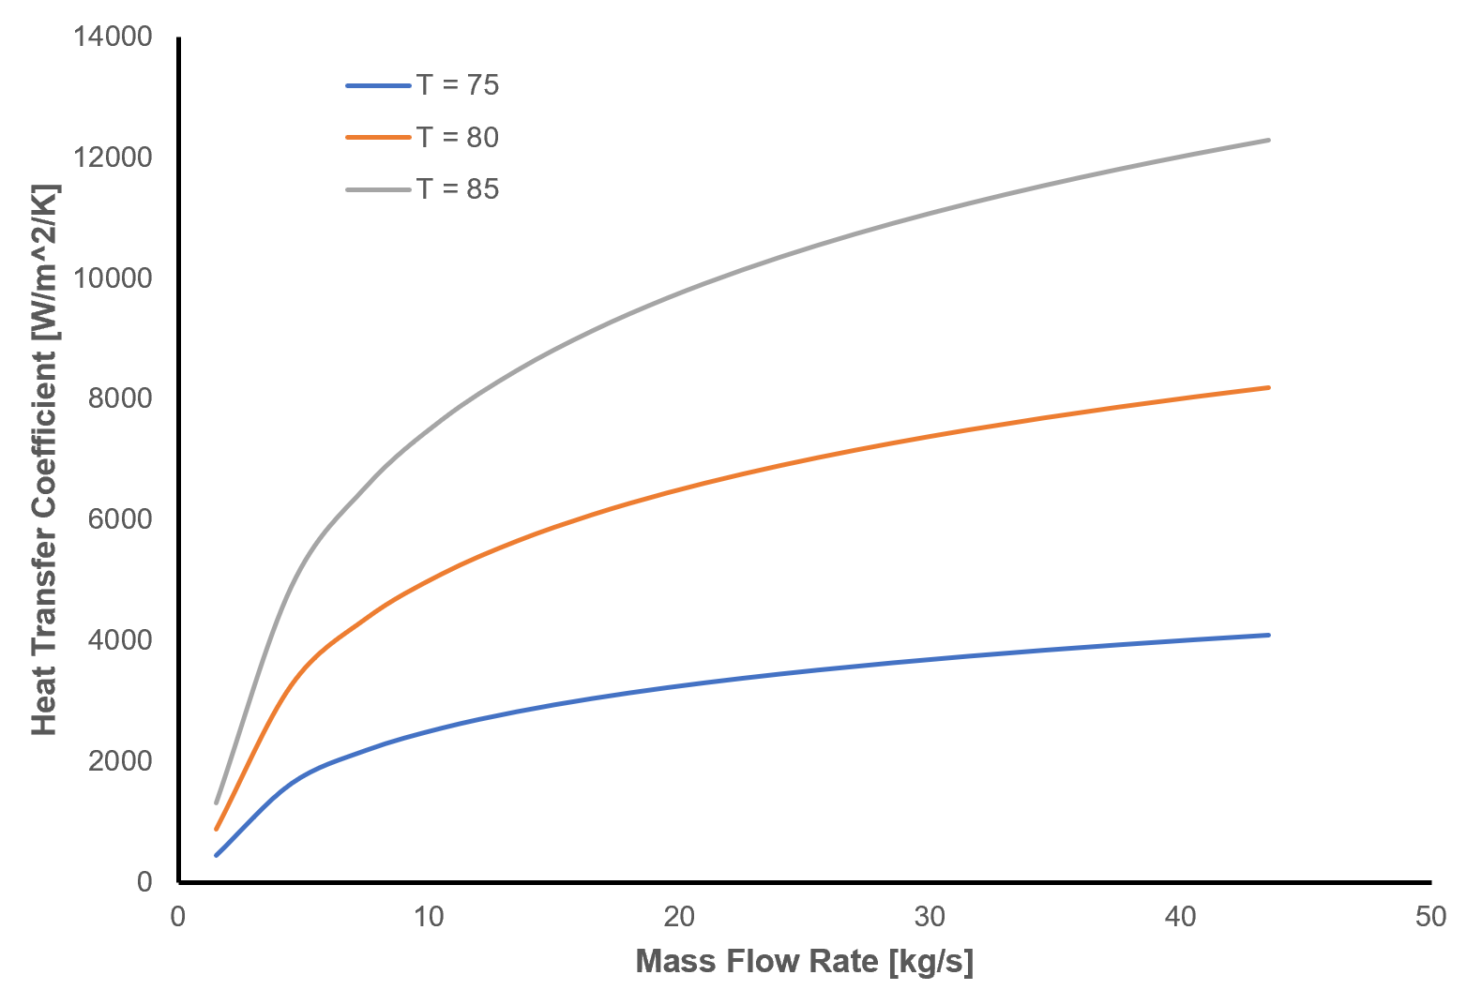

*Figure 12: Heat transfer coefficient relationship between mass flow rate and exit stream temperature*

Maintaining consistent filtration throughout the concentration process is dependent on a variety of factors, one of which is transmembrane pressure. Based on data from a variety of published milk microfiltration protein fractionation equipments, a hypothetical performance curve for variation in transmembrane pressure over time was developed. These results, depicted in Figure 13, compare pressure variation between membrane pore sizes. As pore size decreases, the pressure differential increases. Transmembrane pressure for microfiltration should remain around 0.5 bar. Additionally, this figure depicts the fouling process during filtration. Over time, sediment deposits on the filter prevent efficient passage and increase transmembrane pressure for all filtration processes.

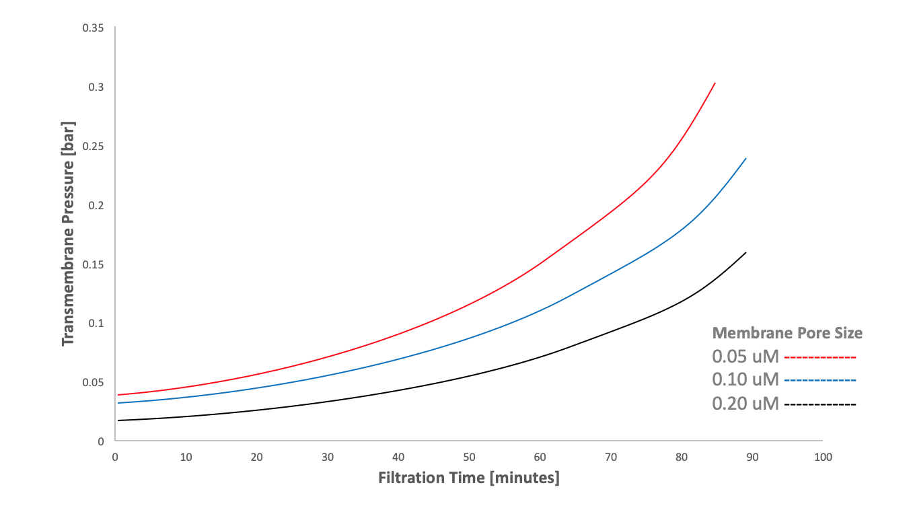

*Figure 13: Hypothetical changing transmembrane pressure over time in microfiltration systems of varied pore size*

In the future, experimentation will be tested by comparing the protein content of the inlet and outlet streams for the filtration process. The Kjeldahl Method will be used to compare the overall protein content of each stream. Since this microfiltration process is fractionating protein, the individual casein and whey contents of the streams will also be observed by comparing SDS-Page gels of each stream or using an alternative chromatography method.

## Fermentation

#### Performance Curve

Based on literature, the following performance curve, Figure 14, shows predicted lactic acid production over time with varied temperatures. This performance curve is essentially an average across several strains of bacteria of lactic-acid bacteria in milk.

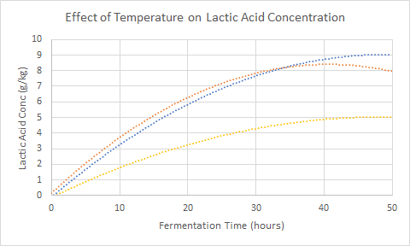

*Figure 14: Effect of Temperature on Lactic Acid Fermentation over Time*

#### Design Equations

Given a mass of 1713.6 kg per batch, the tanks are designed to be 2000L with a height: diameter ratio of 2:1. For the heat exchangers before and after fermentation, the area over which heat transfer occurs must be 0.098 m2 and 1.87 m2 respectively.

## Spray Drying

### Equipment Design

As the equipment will be processing the yogurt with 1505.35 kg of air per hour and the residence time of each particle in the dryer is about ten seconds, the volume of the dryer should be at least 204.73 m3.

1505.35 kg / hour * 1 hour / 60 seconds = 25.08 kg / second

25.08 kg / second * 10 seconds = 250.8 kg / residence

250.8 kg / residence* 1 m3 / 1.225 kg = 204.73 m3 / residence

The equipment should be as tall as reasonably possible (about 10 meters tall) to ensure maximum drying time and exposure to the hot air. If the diameter is assumed to be 5 meters across, then the height should be 10.43 m

204.73 m3 = π * r2 * h

204.73 m3 = π * 2.52 * h

65.17 m3 = 6.25 * h

10.43 m = h

### Theoretical Performance Curve

In addition to height and temperature, the air velocity is another variable that will need to be taken into consideration when designing the spray drying equipment. From the performance curve in Figure 15, it is most ideal to have a high air velocity to decrease the required residence time.

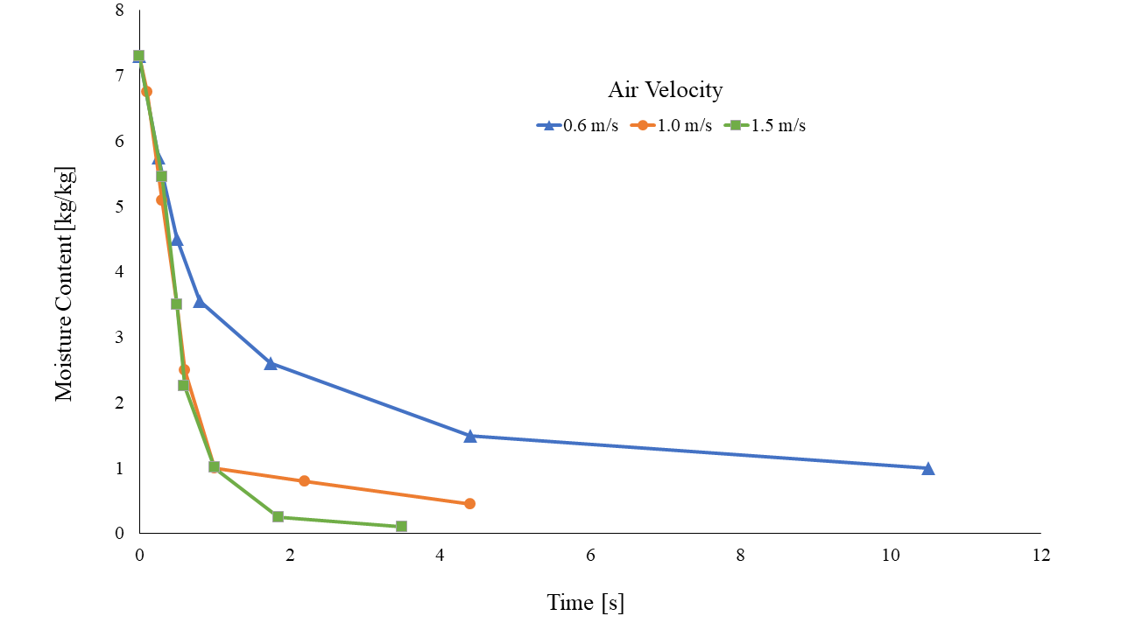

*Figure 15: Spray dryer performance curve of moisture content versus residence time at different air velocities. The theoretical data shows that the product dries faster at a higher air velocity, which is ideal for the process to prevent overheating the product and killing the microbes.*

# Appendix

### Pasteurization Sample Calculations

Regenerative Heating Energy Balance Equation

mmilk * cp,milk * dTmilk,raw = mmilk * cp,milk * dTmilk,sterilized

mmilk = 500 kg

cp,milk = 3.95 kJ/kg/K (Geankoplis, 2003)

Tmilk,raw = 4 C

Tmilk,preheat = ?

dTmilk,raw = 4C - Tmilk,preheat

Tmilk,sterilized = 80 C

Tmilk,cooled = 50 C

dTmilk,sterilized = 50 C - 80 C = -30 C = -30 K

**Tmilk,preheat = 34 C**

mfrmilk = 0.139 kg/s

dTavg = [(Tmilk,cooled - Tmilk,raw) + (Tmilk,sterilized - Tmilk,preheat)]/2

dTavg = [(50 - 4)+(80 - 34)]/2 = 46 K

U = 267 W/m2K (Geankoplis, 2003)

dTsterilized,milk = 80 - 50 = 30 K

**AHX = 0.00315 m2**

Pasteurization Energy Balance

mmilk * cp,milk * dTmilk = msteam * cp,steam * dTsteam

mmilk = 500 kg

cp,milk = 3.95 kJ/kg/K

Tmilk,preheat = 34 C

Tmilk,sterilized = 80 C

dTmilk = 34 - 80 = -46 K

cp,steam = 1.926 (Geankoplis, 2003)

Tsteami = 200 C

Tsteamo = 180 C

dTsteam = 20 K

Solving for msteam

msteam = 2358.5 kg to heat the preheat milk to the sterilized milk temperature

Assuming 1 minute to heat up 500 kg of milk **mfrsteam = 39.3 kg/s**

U = 267 W/m2K (Geankoplis, 2003)

dTavg = [(Tsteamf - Tmilk,preheat) + (Tsteami - Tmilk,sterilized)]/2

dTavg = [(180 - 34) + (200 - 85)]/2 = 130.5 K

dTsteam = 200 - 180 = 20 K

**AHX = 1.85 m2**

Holding Tube Length

Q = 0.0010515 m3/sec

r = 0.0635 m

tHT = 25 sec

LHT = Q * tHT / π / r2

**LHT = 2.08 meters**

Heat Exchanger Power

First Heat Exchanger

dThot = 80 C - 50 C = 30 C

dTcold = 34 C - 4 C = 30 C

Q = 3.78 m3/h * 1030 kg/m3 (density of milk according to Douglas Goff. University)

= 3893.4 kg/h

cp,milk = 1.0972e-3 kWh/kg/K

Phot = Q * cp,milk * dThot

Pcold = Q * cp,milk * dTcold

Phot = 128.2 kW

Pcold = 128.2 kW

Ptotal = Phot + Pcold = 256.3 kW

**Ptotal = 256.3 kW**

Second Heat Exchanger

dThot = 200 C - 180 C = 20 C

dTcold = 80 C - 34 C = 46 C

Qcold = 3893.4 kg/hr

Qhot = 141480 kg/hr

cp,milk = 1.0972e-3 kWh/kg/K

cp,steam = 5.35e-4 kWh/kg/K

Phot = Qhot * cp,steam * dThot

Pcold = Qcold * cp,milk * dTcold

Phot = 1513.8 kW

Pcold = 196.5 kW

Ptotal = Phot + Pcold

**Ptotal = 1710.3 kW**

### Fermentation Sample Calculations

Energy balance for countercurrent cooling to 40C

Milk at 50C + water at 10C → Milk at 40C + water at 40C

$m_{milk}C_{p,m}ΔT_{m}=m_{water}C_{p,w}ΔT_{w}$

277.6 kg/h * 3.93 kJ/kgK * (50-40)= mwater kg/h *4.1855 kJ/kgK *(40-10)

mwater = 86.9 kg/h

$m_{water}C_{p,w}ΔT_{w} = UAΔT_{ln} =$ 10909.7 KJ/h = 3030.5 J/s

$ΔT_{ln}$ = 10 - 30 / ln(⅓)

where U is ~1700 W/m2K from Geankoplis pg 300, A = 0.098 m2

Energy balance for countercurrent cooling to 15C

Yogurt at 40C + water at 10C → Yogurt 15C + water at 25C

$m_{yogurt}C_{p,y}ΔT_{y}=m_{water}C_{p,w}ΔT_{w}$

277.6 kg/h * 3.93 kJ/kgK * (40-15)= mwater kg/h *4.1855 kJ/kgK *(25-10)

mwater = 434.4 kg/h

$m_{water}C_{p,w}ΔT_{w} = UAΔT_{ln} =$ 27274.2 KJ/h = 7576.1 J/s

$ΔT_{ln}$ = 15 - 5 / ln(15/5) = 9.1

where U is ~1600 W/m2K from Geankoplis pg 300, A = 1.87 m2

### Yogurt Fermentation Raw Data

|  |  |  |  |  |  |  |
| --- | --- | --- | --- | --- | --- | --- |
| **Beaker** | **1** | **2** | **3** | **4** | **5** | **6** |
| **initial pH** | 5.19 | 5.4 | 5.75 | 5.9 | 6.1 | 6.42 |
| **20 minutes pH** | 5.11 | 5.3 | 5.45 | 5.88 | 6.07 | 6.36 |
| **20 minutes T** | 30.6 | 26.1 | 23 | 23.7 | 25.2 | 26.6 |
| **40 minutes pH** | 5.12 | 5.3 | 5.74 | 5.86 | 6.05 | 6.35 |
| **40 minutes T** | 36.2 | 27.2 | 28.7 | 29.1 | 28.2 | 30.3 |
| **60 minutes pH** | 4.96 | 5.19 | 5.59 | 5.67 | 5.86 | 6.15 |
| **60 minutes T** | 39.5 | 38 | 34 | 32 | 33.3 | 34.8 |
| **80 minutes pH** | 4.92 | 5.14 | 5.51 | 5.58 | 5.78 | 6.05 |
| **80 minutes T** | 41.3 | 37.9 | 36.5 | 36 | 36.1 | 37.6 |
| **100 minutes pH** | 4.88 | 5.11 | 5.41 | 5.49 | 5.65 | 5.87 |
| **100 minutes T** | 41.6 | 39.6 | 37.3 | 37.7 | 37 | 39.2 |
| **120 minutes pH** | 4.81 | 5.04 | 5.26 | 5.36 | 5.49 | 5.73 |
| **120 minutes T** | 43.4 | 44 | 38.3 | 40 | 39.5 | 40.3 |
| **140 minutes pH** | 4.74 | 4.93 | 5.15 | 5.2 | 5.31 | 5.49 |
| **140 minutes T** | 41.9 | 44.4 | 40.9 | 38.7 | 39.1 | 41.1 |